Amazon S3 **– simple storage service** is an object based data storage service designed to store and retrieve any amount of data from anywhere in the internet. It is extremely durable, highly available and infinitely scalable at low cost.

Unlimited volume of data and object can be stored in S3. Each individual object can range from a minimum of 0 bytes to a maximum of 5 terabytes. In a single put, a maximum of 5 gigabytes can be written. For objects > 100 MB, multipart file upload should be considered.

S3 storage classes can be configured at object level and each bucket can contain objects stored across

S3 standard, S3 Intelligent tiering, S3 Standard IA and S3 One zone IA. L3 lifecycle policies can be used to transition objects automatically across storage classes.

S3 Intelligent: For a fee per object, infrequently accessed objects are moved to low cost tiers and vice versa. Ideal for data with unknown access patterns.

|  |  |  |  |  |  |  |  |  |
| --- | --- | --- | --- | --- | --- | --- | --- | --- |
| **Type** | **Durability** | **Availa**  **bility** | **SSL for**  **data**  **in**  **transit** | **Encryp**  **tion**  **of data**  **at**  **rest** | **S3 life**  **cycle**  **manage**  **ment** | **Audience** | **Resilient**  **across**  **availability**  **zones** | **Pricing** |
| S3 Standard | 99.9999  99999%  (11 9s) | 99.99% | Y | Y | Y | General  Purpose | Y(Min = 3) | First 50 TB/ Month : 0.023/GB,  Next 450 TB : 0.022/GB,  Over 500 TB :  0.021 /GB |
| S3 Intelligent  Tiering | 99.9999  99999%  (11 9s) | 99.99% | Y | Y | Y | Unknown or changing access patterns | Y(Min = 3) | Frequent :  First 50 TB/ Month : 0.023/GB,  Next 450 TB : 0.022/GB,  Over 500 TB :  0.021 /GB  In Frequent :  0.0125 per GB  Monitoring :  0.0025 per 1000 objects |
| Standard  IA | 99.9999  99999%  (11 9s) | 99.9% | Y | Y | Y | Data accessed less frequently but rapidly accessible. | Y(Min = 3) | All /Month :  0.0125 per GB |
| One  Zone IA | 99.9999  99999%  (11 9s) | 99.5% | Y | Y | Y | Easily recreatable/ recoverable data which is otherwise same as standard IA | N(Max = 1) | All /Month :  0.01 per GB |
| Glacier | 99.9999  99999%  (11 9s) | Can be  restored  within few minutes to hours  (configu  rable) | Y | Y | Y | Archive | Y(Min = 3) | All /Month :  0.004 per GB |
| Glacier  Deep  Archive | 99.9999  99999%  (11 9s) | Can be restored within 12 hours | Y | Y | Y | Long term Archive(7-10 years or longer) | Y(Min = 3) | Coming soon |

S3 Bucket: Folder in which we store our objects (files). S3 service is global but S3 buckets are region specific.

**S3 service splash screen:**

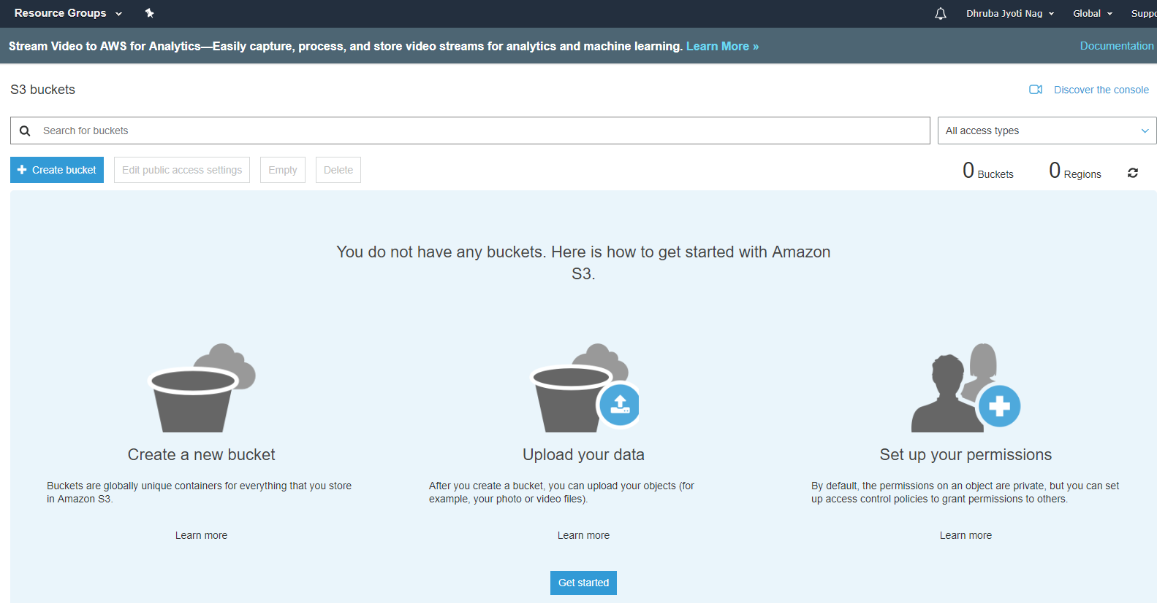

**Creating bucket:**

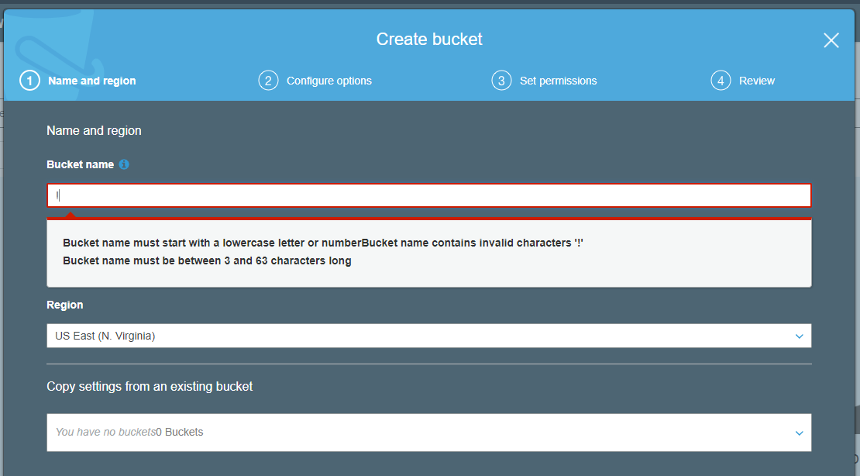

We need to

* Provide bucket name which needs to start with lower case letters or number.
* select Region

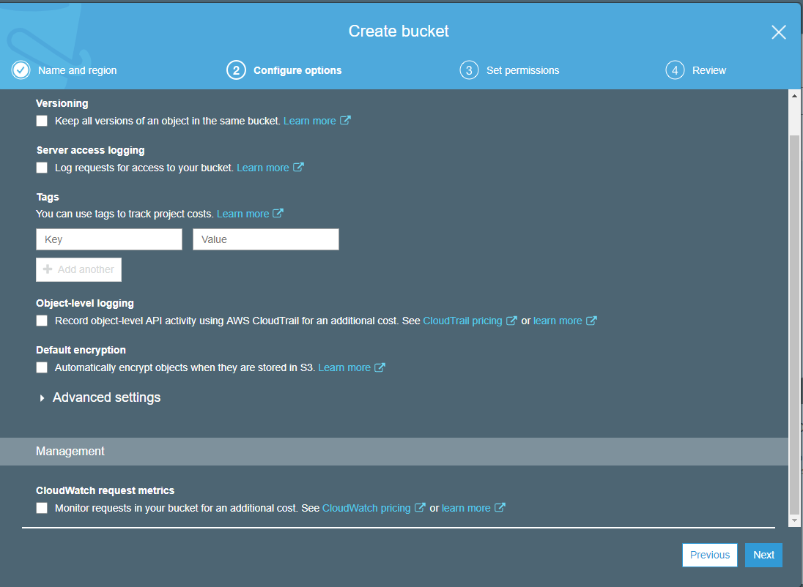

We can implement logs on each individual object in an s3 bucket.

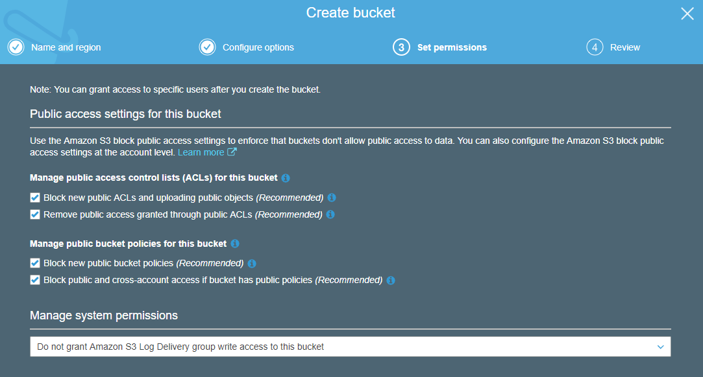

A S3 bucket cannot be made public by default. We need to uncheck the settings here to make objects in the bucket publicly accessible and then we can apply **make public** on concerned objects.

Then the bucket will be displayed as follows:

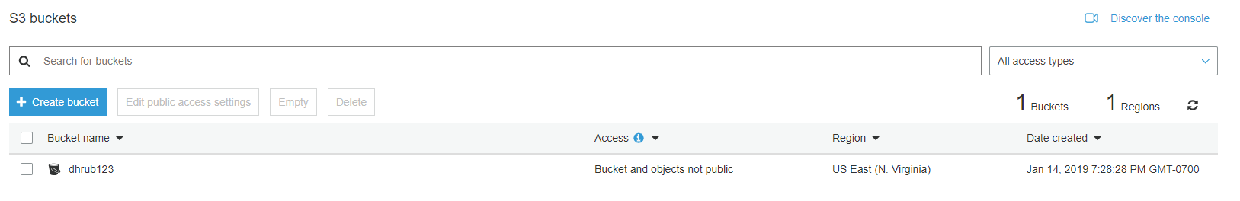

**Properties of a bucket:**

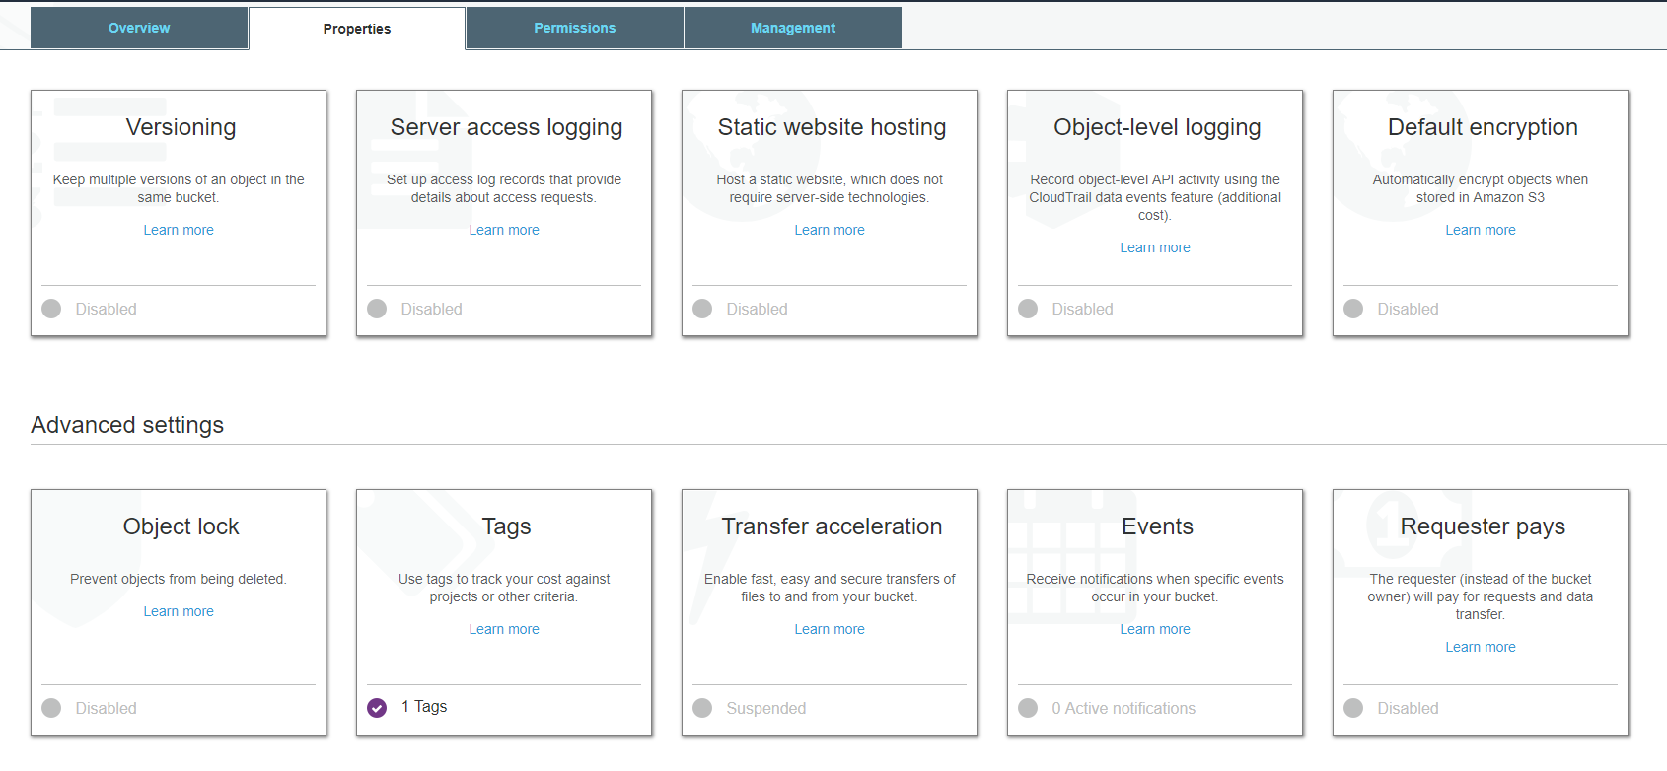

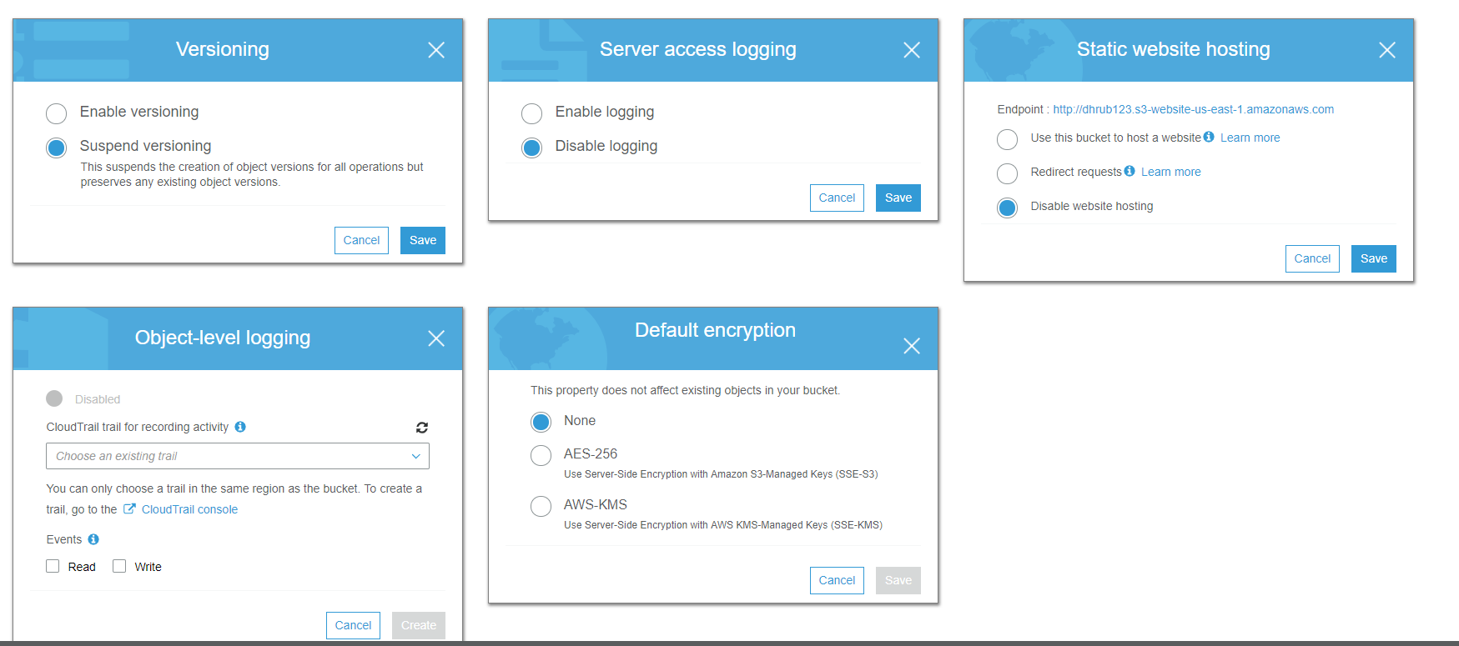

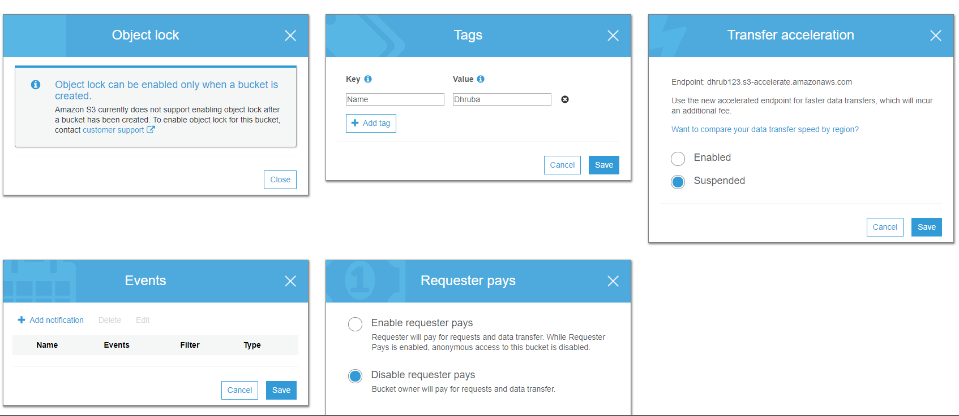

**Permissions:**

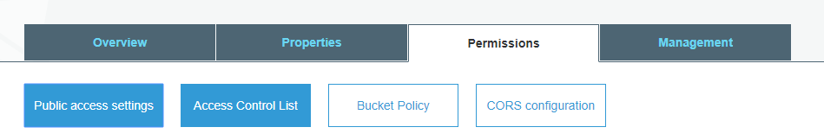

* Public access settings: control public access to data
* Access Control List: Allow basic read/write access to bucket from other aws resources using acl.
* Bucket Policy: JSON based access policy document to allow advanced access to AWS bucket
* CORS: Cross Origin Resource Sharing for access from other domains

**Management:**

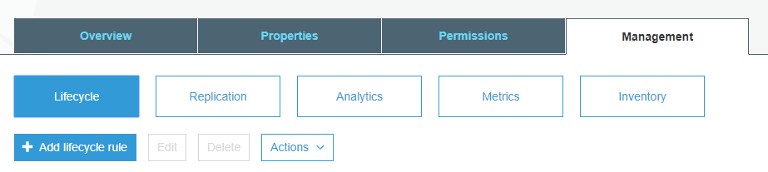

Management is mainly concerned with lifecycle management.

**Uploading an object to a bucket:**

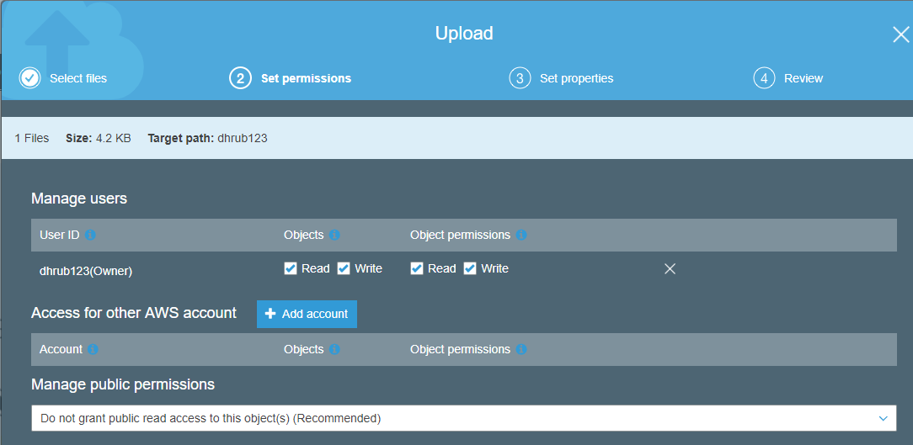

Whenever we upload an object successfully to a bucket, we get HTTP response code 200 (success).

**The size of a S3 object can also be 0 bytes.**



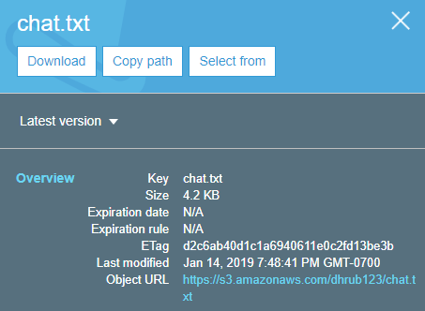

Now this object is not public, so if we try to access the URL, we will get below page.

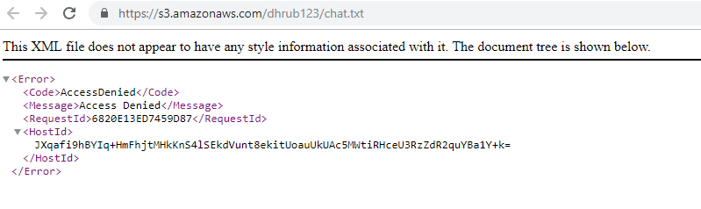

If we ever try to upload an object with (Grant public read access to this object) in a nonpublic bucket,

We will always get error.



To change that, we have to edit bucket permissions and uncheck all.

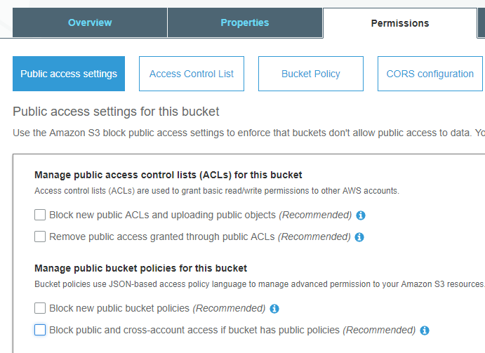

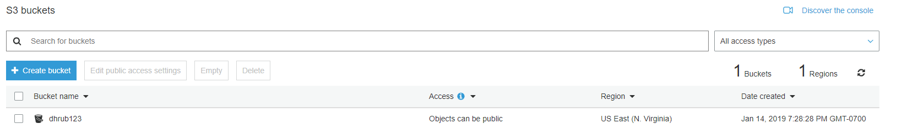

Now if we try to make the object public and access the object, we can do so.

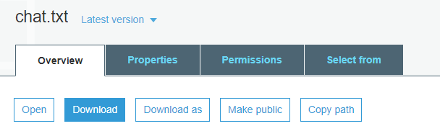

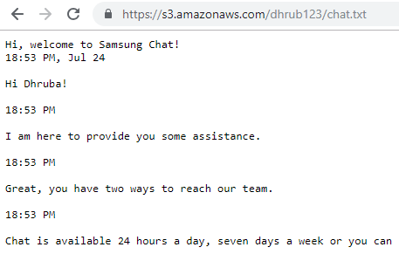

**All objects and the bucket are private by default.**

All data on AWS can be encrypted – server or client side.

When encrypted data is uploaded, it is regarded as client side encryption.

Server side Encryption:

* SSE-S3 – with amazon s3 managed keys
* SSE-KMS – with KMS
* SSE-C – with customer provided keys